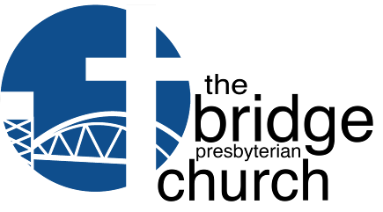


thebridgepres@gmail.com thebridgepres.org
910-769-4951
Letting God’s currents carry us through Life

The Mission of the bridge Presbyterian Church is to help active adults connect with God’s
people, discover God’s presence, learn God’s promises, and embrace their unique God-given purpose for their lives.

Worship Together Weekly
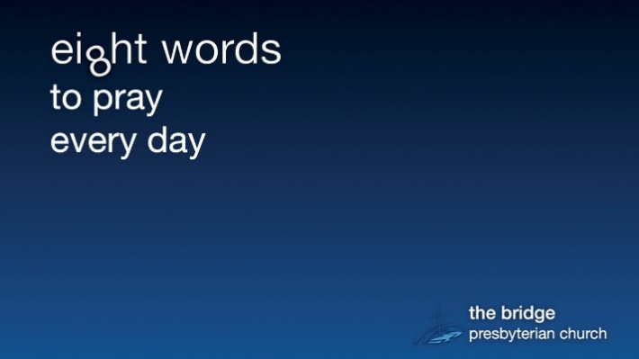
Sunday, Nov 1, 2026

The Eighth Word: LOVE!

II Samuel 9: 1 – 12; John 15: 12-17

9:00 am - Early Worship Service

10:30 am - Second Service

Second services in person and livestreamed on Facebook and YouTube

Links to all videos posted by the bridge on YouTube:

https://www.youtube.com/@thebridgepresbyterianchurc4433/streams

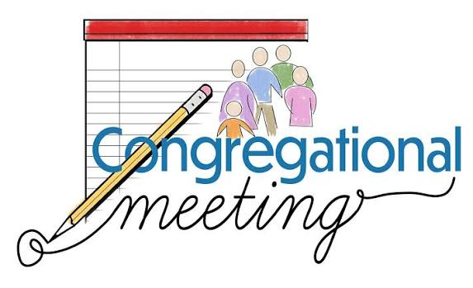

Congregational Meeting
Sunday, November 1, 2026

immediately following the 10:30 service

The purpose of the meeting is to
elect Elders for 2027.

Bios of each will be in next week’s Currents.

Welcome and Include All
Welcome One Another – a Message from Dr. Doug

Do you remember how alone you felt when you moved to Leland? Do you recall what a blessing it was when a stranger introduced themselves to you; welcomed you or invited you to join a gathering?

At the bridge, we receive new visitors almost every week. But lately, it seems like there has been an uptick in new visitors. Did you know that most visitors subconsciously decide whether to return to a church within the first eight minutes of their visit? Yea, it’s true!

This means that everyone at the bridge has a big part to play in making our visitors feel welcome and included. This means that God is using you when you take a moment to simply say hello or to welcome our visitors. This means that you are showing the love of Christ every time you shake someone’s hand and say: “Good morning.”

Because we are growing, it’s not easy to know who is visiting and who is a covenant partner at the bridge. The last thing anyone wants is to welcome someone by saying: “Are you new to the bridge,” only to find out they joined a year ago. That’s embarrassing.

There are, however, more effective ways of welcoming our visitors. For example, you can make it a habit of simply saying: “Good morning,” to people you don’t know. Better yet, you could make a habit of simply introducing yourself to one person you don’t know every Sunday: “Hi I’m ________.” Or, “I don’t think we’ve met, I’m _____.”
Here’s a challenge for everyone at the bridge. For the next month pay attention to where your eyes take you on Sunday morning. Do your eyes naturally gravitate toward people you know or people you don’t know? Try looking for someone you don’t know, someone who looks a bit lost or a bit by themselves, then offer them a simple greeting.

Remember how you felt when you moved to Leland? Remember how wonderful it was to be greeted by a stranger or welcomed by a new neighbor? Remember what we read in Romans 15:7: "Therefore welcome one another as Christ has welcomed you, for the glory of God.”
Grace and Peace,
Dr. Doug
Please Participate in Our Stewardship Wall Art!

This year our stewardship theme is: There Our Heart Will Be. This year we want everyone in the church to participate in exploring the relationship between our heart and our giving. One way the stewardship team invites your participation is by answering a simple question: Why I the Bridge? More specifically, you are invited to answer that question by writing your response on the wall within our worship center.

For the next few weeks, you will see a banner hanging on the north wall of our worship center with the above question. The stewardship team is encouraging you to take one of the sharpies and write your one sentence answer on the banner. Let’s have everyone sign the banner and then learn why we love the Bridge so much!

As you consider your giving to the bridge, remember that “where your treasure is, your heart will also be.” Matthew 6:21

There Our Heart Will Be
In Matthew 6:21, Jesus says: “Where your treasure is, there also will your heart be.” That is the verse our stewardship team picked to be the theme of stewardship season 2026 at the bridge.

During stewardship season, the stewardship team will be inviting you to write a simple sentence prayer to our Lord offering your heart and life to God. Beginning this Sunday, the ushers will be handing out heart-shaped cards with our stewardship theme printed on the front. We are asking you to write a one-sentence prayer dedicating your heart to our Lord on the back of the heart-card.

Then, on Commitment Sunday, please bring your heart-card along with your pledge-card to worship. At the end of the service, you are invited to drop off both cards in a box on your way out of worship. Then, on the following Sunday, we will share some of those anonymous prayers with the congregation in worship.

We hope you will participate in this part of our stewardship season. You don’t have to put your name on the prayer, and nobody will know who wrote any of the prayers. The purpose of this fun stewardship activity is to celebrate how the Lord is growing God’s love in our hearts.

May the Lord bless our church and the hearts that make up our wonderful congregation.
The Stewardship Team
ADVENT 2026


The holidays are typically a time when we reflect on the blessings of our life. However, many of us, like George Bailey, don’t feel our life is going the way we hoped. Maybe it’s a dream deferred; a relationship torn or a health challenge that makes us feel discouraged about life. Maybe we are little like George Bailey in the holiday classic: It’s A Wonderful Life? Beginning November 29th and running through the Advent and Christmas season, the Bridge Presbyterian Church will explore the life of George Bailey to find where and how God was blessing him and showing him what a wonderful and blessed life, he was living. Each Sunday we will show a clip from It’s A Wonderful Life along with a visit from a character in the movie.
As we explore Scripture, we will see how God is at work in our life and in the world with the hope that by Christmas Eve, we will be able to see how the gift of the Christ child, gives us “a wonderful life.”

Movie at the bridge

Come watch It’s a Wonderful Life on Wed, Nov 18th at Noon.
Bring your favorite snacks and drink!

Please sign up in the hallway or online – we need 12 attendees to hold the event.

Elder Elect Bios

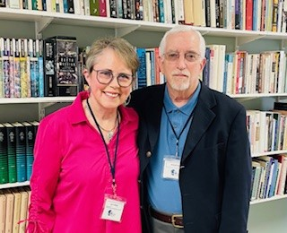
Brod Hale – Worship Team

I was born and raised in Bluefield, WV, and across the state line in southwestern Virginia. I was baptized in the same Presbyterian church as my mother who, 25 years prior, was the first infant baptized in the new church sanctuary building.

After graduating from college, I went to work as a medical technologist for a relatively new medical laboratory based in Burlington, NC. I remained with the same company, through several mergers and numerous acquisitions, until my retirement in 2018 after 44 years. While working on a project for that company I met my wife, Lynn, who was a medical technologist and manager at one of the company’s recently acquired laboratories in Denver, CO. After successfully maintaining a long-distance relationship, in 1987 we were married in Richmond, VA, where my mother lived. The service was held at a historic Presbyterian church (est. 1747 as a meeting house) where my uncle was pastor.

Throughout our marriage Lynn and I have primarily attended Presbyterian churches. When we moved to Leland after my retirement, we spent several years trying to find a church that felt right, but it wasn’t until we decided to try the church on Lanvale Rd. that we succeeded. At the end of that first Sunday visit, everyone we met was so friendly and we enjoyed the service so much, we knew we had found what we had been seeking.

It is an honor to be considered for the position of Elder in the church. I must admit that I’m a little unnerved by the prospect but feel that it’s a wonderful opportunity to serve.

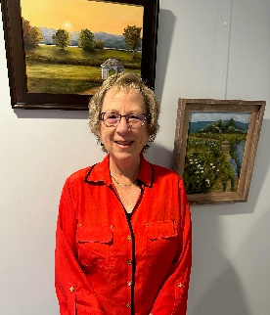

Kerrie Dunne - Mission Team

John and I moved from Connecticut to North Carolina about four years ago after we both retired. Our daughter Christy, husband Mike, and grandson Tyler live in Connecticut. Our son Trai is in the Marines and is currently stationed at Quantico, Virginia.
In Connecticut, I attended an active Congregational Church and became involved in the Outreach Committee; from growing food in our church garden to taking food and clothes to the homeless shelters.
When we moved to North Carolina, I searched for a church with a strong outreach program and found the bridge Presbyterian Church. I have been amazed at the energy and love this church has given to its mission partnerships and I am excited about serving as an Elder with our Missions Team.

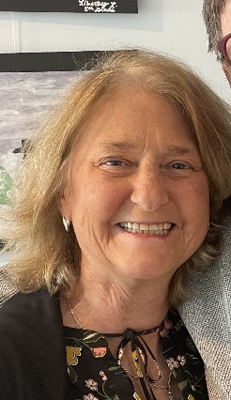
Ann Tydings – Prayer and Care

I’m Ann Tydings! Mike and I have been members of the bridge for 4 years. I was born and lived in NC until we were married after college (Go TarHeels! ) We spent most of our married life living and raising our kids in Texas. After the kids were all in school, I went back to college to get my teaching certification. I traded in working in the business world to teaching elementary kids. This was the job of my dreams! I taught until Mike and I retired. ( I still get anticipatory excitement when the school supplies come out in the fall!). We moved back home to NC 5 years ago. I love being a member of the bridge. Our church has a warmth that is an excellent example of Christ’s love for His people. I look forward to serving our church in any way that God calls me.
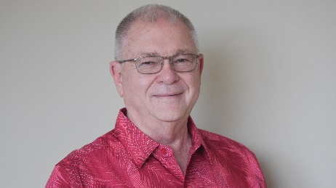

Charlie Riddle – Human Resources

I was a Methodist all my life, from baptism until a period before moving here in 2014, when I attended a Presbyterian Church. I felt God’s calling to help and direct others in learning life and God’s will. I started my road of education by teaching 5th grade Sunday School when I was 15.
I was Chairman of Outreach for a period of 12 years, organizing help to those in need, both locally and in other countries. I went on to teach high school history, be a Vice-Principal and high school Principal before retiring. I was also elected and served 16 years on a borough council as head of finance and ordinance, thus helping my community in many ways.

Moving to Leland in 2014, I started my search for a church home. As I approached the parking lot, my car turned right to park in front of the bridge. I was greeted by some very warm and friendly people asking “Are you coming to the bridge?” to which I answered “I guess so”. The warmth I found that Sunday drew me back the next Sunday and helped me realize I was where God wanted me to be!

From that point on, I have been involved. I have co-facilitated and facilitated small group studies. I sing in our Celebration Chorus and answered the call to serve on numerous committees. In 2019, I was ordained and Elder and for 6 years headed Long Term Planning / HR. This has been my year off and now I was asked to serve again as Elder of HR. I now feel I have the direction from God to help us all as we develop and enlarge our church. May God Guide and be with us all as the bridge moves forward.

Find Purpose through Service

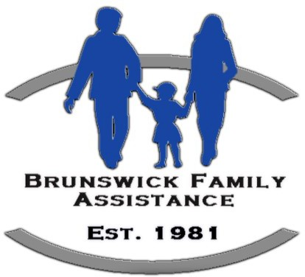
November Mission Partner Brunswick Family Assistance

Our November sustainable mission partner is Brunswick Family Assistance Christmas Program.
BFA has served Brunswick County families in need for over 40 years
There are three ways that you can support the Christmas Program

- Adopt a child/children under the age of 16 or an adult over 60. You will receive a tag with items they have asked for on a questionnaire. You will purchase these gifts and bring them (unwrapped) with the tag to the church.

**** You can pick up the form on the hall table and it needs to be returned to Wanda by Nov 8th at the latest. The purchased items must be returned to the church no later than Sunday, November 29th.

- Donate unwrapped gifts for children (under 16) or adults (60+) to the “Fill the Sleigh” box in the hallway. Gifts need to be here by November 29th.

- Donate money through the offering by making checks to the bridge with BFA Christmas in the Memo line or online scroll down to BFA on the fund list. BFA provides a food basket and a frozen turkey to eligible clients in need even if they have no one in the age groups mentioned above.



Find Purpose through Service



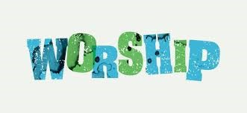

Our next Craft Day at The Bluefields Memory Care will be

Thursday, Oct. 29th at 2:00 p.m. in the Activities Room.

If you would like to join the fun in helping our friends, please arrive by 1:45 and wear your bridge tee shirt, if you have one.
Any questions please email Patti Pirher at ppirher@gmail.com

Our next Worship Service at The Bluefields Memory Care will be Thursday, Nov 5th at 1:30p.m. in the Activities Room. Volunteers are needed to help the residents with songbooks, purchase/serve cookies, sing along, and enjoy worshiping God with our Bluefields friends.
If you would like to join us in this ministry, please wear your bridge tee shirt, if you have one, and arrive by 1:20p.m.For more information or if you are bringing cookies for the residents, contact Susan Stanewick at sstanewick@gmail.com

TONIGHT
Oct 29th at 6:00

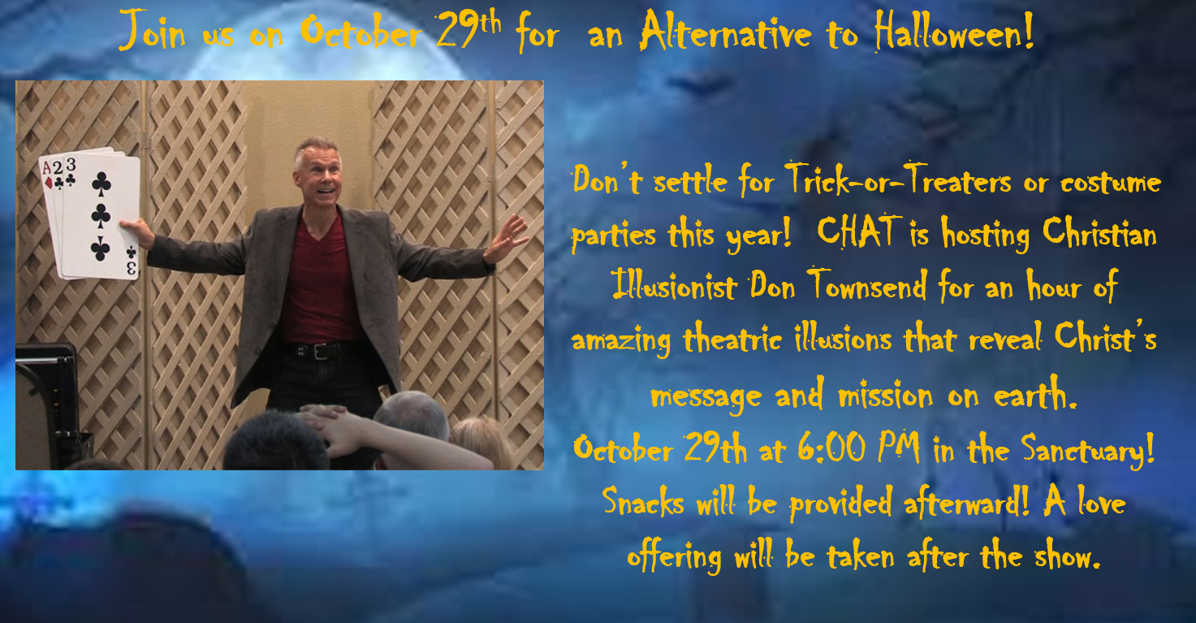


Tech Talk is returning in November! For those who may have missed it last year, we’re offering our beginner computer training every Tuesday at 10:00 AM in November. Program Information will be available at the Sign-Up table. Sign up for individual classes or the whole series. Sign up sheet is in the hall or sign up on Realm. Must have a minimum of 5 to hold each class.

Module One - Learning Objectives: Staying Safe Online (1.5 hours) 11-3-26
At the end of this module, participants will be able to:
• Describe two different types of malware
• List at least one type of anti-virus program
• Explain why one search engine might be preferred over another one
• Follow written guidance to change a default search engine
• Recognize suspicious website or email addresses
• List three tells that might indicate a scam
• Explain how to create a strong password
• Recognize and use multi-factor authorization (MFA)
• Know what to do if you’ve been scammed or hacked

Module Two - Learning Objectives: Computer Basics (1.5 hours) 11-10-26
At the end of this module, participants will be able to:
• Discuss the difference between computer hardware and software
• Locate the specifications for their computer’s processor
• Locate the amount of storage remaining on their devices
• Explain what an Operating System does and list 3 common ones
• Connect to a new network (Get online)
• Use common features on internet browsers
• Use Windows keyboard shortcuts to accomplish common commands
• Explain what “the cloud” is and how it works
• Use basic troubleshooting tips to solve routine issues

Module Three - Learning Objectives: Essential Computer Skills (2 hours) (1.5 hours) 11-17-26
At the end of this module, participants will be able to:
• Describe the Windows file folder method for organizing content on your computer
• List three ways to backing up your files
• Send an email
• Add an attachment to an email
• Open and save an email attachment
• List 3 aspects of photo management
• Explain what a QR Code is
• Open content from a QR code
• Create a QR code
• Place a QR code in a document
• Define “Streaming”
• Subscribe to a streaming service
• Use Zoom for Remote meetings
• Connect a Computer to the Smart TV in Warnock Hall

Module Four - Learning Objectives: Microsoft Office (Word)11-24-26
At the end of this module , participants will be able to:
• Recognize similarities across the MS Office programs
• Change font formatting within a document
• Copy and Paste graphics and text
• Use the Format Painter to copy formatting from one block of text to another
• Apply bullets and numbering
• Indent and outdent text
• Apply shading and borders
• Apply Styles to format text
• Insert a page break
• Understand the difference between a hard return and a page break
• Adjust text to left, right, centered, or justified
• Find specific text within a document
• Replace text already in a document with new text
• Create tables, modify, and use tables
• Insert graphics into a Word document
• Create shapes and drawings in a document
• Capture a screen shot and place it in a document
• Create text boxes to position and hold text and graphics


Advent Centerpiece - Making Class
Thursday, Nov 19th at 2:00
Cost for supplies will be $12.
We ask each participant to bring a small bag or package of Christmas decorations to share. (Pinecones, floral, bows, cinnamon sticks etc.)
Space is limited to 16.
Please sign up in the hallway or on Realm by Sunday, Nov. 15th



Thank you for all the cards, kind words and prayers over the last several weeks, and special thanks to all those who helped make Mom’s Memorial service so special.

Once again, we felt surrounded by your love during a stressful time, and we are so grateful and blessed to be part of The Bridge church family!

May God Bless you all!
Jim and Judy Bath



Space Needed!

Can you help us out with some storage space?

We have a whole lot of donations for our Blessed Bargains Yard Sale and Mission Fair that got rained out. If you could share part of a storage unit or a garage, we could use the space! We might even be willing to share costs for a storage unit. If you have space you’re willing to share, please reach out to Bruce Garris at 910-297-3551.

If you had items collected for the Blessed Bargains event and would like to save them for our follow up event this this Spring (March 7th!), or if you are still going through your home and have found new things to donate, we have a place for you to take those items!

Cathy Boettcher has agreed to allow us to use her storage building, and we have set a schedule for taking over to her home:

Saturday, November 7th, cleaning the storage building and prep from 10-11am (a couple of volunteers needed!), Then drop-off of items any time between 11am and 2pm

Note: Tuesday November 10th, and Thursday November 12th are also available for drop-offs by appointment only.

Please call to schedule your drop off with Cathy Boettcher at (910) 471-5951

Celebrate Life’s Milestones

October
Birthdays Anniversaries

Eric Peterson | 29
Dick Hubbard | 30

November

Birthdays If you have a Nov. Anniversary – Please
let Wanda know at thebridgepres@gmail.com
Anne Dutra | 2
Patti Pirher | 4
Marge Hall | 8
Elizabeth Murray | 13
Ruth Fitzsimmons | 15
Judy Bath | 17
Dianne Betz | 17
Del Shaffar | 17
Peter Barrett | 22
Sharon Cushing | 22
Donna Maher | 22
Sheila Davis | 24
Jim Manaro | 28
Lynne Lewis | 29
Steve Wingert | 29

Upcoming Happenings

October
29th- Bluefield Craft - 2:00 pm
29th – Christian Illusionist – 6:00 pm

November

1st - Daylight Savings
3rd - Tech Talks - 9:00 - (4 weeks)
3rd - WOTB - Blessing Bags
4th - Session - 3:00
5th - Bluefield Worship - 1:30
6th- New Hope Mobile Clinic
18th - It’s a Wonderful Life – Movie Showing at Noon
19th – Advent Centerpiece Making Class 2:00
22nd - Stewardship Celebration Sunday
26 and 27th - Office Closed - Thanksgiving
29th - 5th Sunday - One Service at 10:30 - First Sunday of Advent

