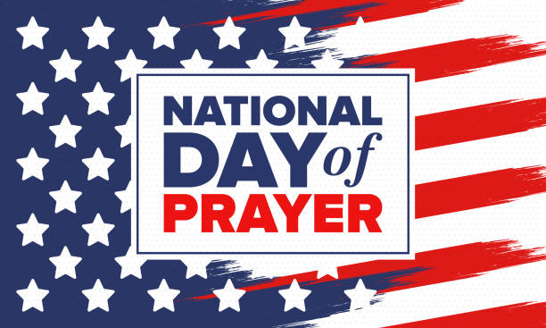

Take time today and everyday to pray for our Nation and our World.

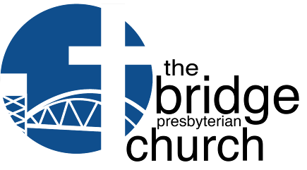


thebridgepres@gmail.com thebridgepres.org
910-769-4951
Letting God’s currents carry us through Life

The Mission of the bridge Presbyterian Church is to help everyone connect with
God’s people, discover God’s presence, learn God’s promises, and find their unique God-given purpose for their lives.

Worship Together Weekly
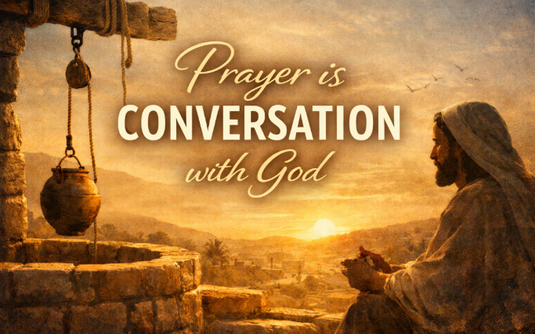

Sunday, May 10th
Prayer as a Conversation

9:00 am - Early Worship Service

10:30 am - Second Service

Second services in person and livestreamed on Facebook and YouTube

Links to all videos posted by the bridge on YouTube:

https://www.youtube.com/@thebridgepresbyterianchurc4433/streams

Exciting Things Happening
In Worship In May

You won’t want to miss worship at the bridge in May. We have a lot of fun and inspiring worship planned. So, join your church family in worship this May.

May 10 – We will be installing Elder Gary Westphal and celebrating the Lord’s Supper. Dr. Doug will be preaching an interactive sermon titled: “Prayer as Conversation.”

May 17 – Dr. Doug will preach a sermon titled: “We’re Still The Same!” reflecting on God’s grace lived out at the bridge. After second-service there will be a short informational gathering for anyone wanting to know more about Dr. Doug’s upcoming sabbatical.

May 24 – a Sunday at the bridge! Please plan on wearing read to worship as we celebrate the fire of the Holy Spirit breathed into the Church.

May 31 – Fifth Sunday worship means one service only at the bridge. Plan on wearing your favorite team swag to worship as Dr. Doug compares cheering on our favorite sports teams to cheering on God in worship. Don’t forget the pot-lock after worship. The Celebration Choir will also be singing.

WANT TO KNOW MORE ABOUT THE BRIDGE?
JOIN US FOR OUR NEXT “CONNECTING WITH THE BRIDGE” SMALL GROUP SESSIONS

MONDAY, MAY 11th & MONDAY, MAY 18TH AT 11:00 AM

We will be hosting our next Connections Small Group Sessions in May. This informal small group is a wonderful opportunity for you to connect with others who are looking for a new church home and to spend some time getting to know Pastor Doug and each other.

We will be sharing a light lunch as we introduce ourselves and meet a few of our Elders. Pastor Doug will share a little about our church history and what it means to be a Presbyterian. We will also share information about our mission and vision at the bridge and ways you can connect with God’s passion, people, and purpose here at the bridge.

I am so hoping you will consider joining us! There is a sign-up sheet on the long table in the hallway as you come in the double doors where you can let us know that you will be coming. You can also reach out to me, Judy Bath, at jannbath@hotmail.com for more information.

Blessings!
Judy Bath, Connections Team Leader


Find Purpose through Service
Sunday, May 10, 2026
Coffee Servers
9:00 – Laura
10:30 - Linda F.
Greeters/Ushers
9:00 – Halls
10:30 – Betzs
Liturgist
9:00 – Lynn H
10:30 – Charlynne C
Are you ready to be Connected by Serving?
*Help with Coffee * Greet People * Usher*
Let Wanda in the office know and she will get you connected.

Give Gratefully

 | 5/3/26
Total Weekly Giving | $8,225 |  | 9:00 am Service | 39
 |  |  | 10:30 am Service | 61
Weekly Offering (4 wk avg) | $6,284 |  | Total Attendance | 100
 |  |  | Attendance (4 wk avg) | 101

PRAYER LIST May 7, 2026
Pray Daily
Please remember that this prayer list can also be seen on the Bridge Website within Currents. Avoid including private information in your requests unless you plan it to be public knowledge.

Health and Healing

• Prayers for Ed Weihs for successful treatment for newly diagnosed illness
• Prayers for Peggy Fulton as they await surgery at Cleveland Clinic.
• Anne Graham: For continued healing at home.
• Marilyn Vernon: For strength and comfort during her cancer journey.
• Lynn Hale: For comfort and strength following a diagnosis of Mesothelioma,
cancer of her abdomen and small intestine.
• Carol Guilmette: For strength as she continues to manage her illness.
• Sandy Barrett: For peace and successful treatment following the return of her
cancer.
• For Sallie Bohn awaiting knee replacement next week.
• For Elena Tribuna, friend of Mary Ellen Cole, a Russian refugee, battling
advanced cancer after a misdiagnosis
• Prayers for Joyce Rodman's sister and brother-in-law, Becky and Lonnie, who
both have advanced stage cancer.

Our Community and World

• Street Reach: For their ongoing mission to serve the homeless.
• The Vulnerable: For those who are homeless or forgotten.
• Global Concerns: For peace within our country and the world

You will not impact the world by faithfully going to church. You will impact the world by faithfully BEING the church when you go out into the world.

To make a prayer request, contact Elder Mary Campbell at carlislecampbell@gmail.com or (910)269- 9696 text or phone. There are also yellow request cards available in the church hallway across from the coffee bar. You can also send a request through our website. Prayer requests remain in Currents
for two weeks unless an extension is requested.

Find Meaningful Relationships in Small Groups

You asked for it … We listened ... and now you’ve got it!!

Beginning the week of May 11th, we will be offering a
short 4-week Bible Study!

We are going to be focusing on 4 intriguing women of the Bible:
Leah
Rachel
Mary Magdalene
Priscilla
Each week will feature one of these women.

There will be two groups offered:
- Tuesday at 10:00 am – Facilitated by Tom and Greer Broadwater
- Thursdays at 11:00 am – Facilitated by Suzanne Veen

Signup sheets are in the hallway, or you can call contact the church office to sign up.

Find Meaningful Relationships in Small Groups

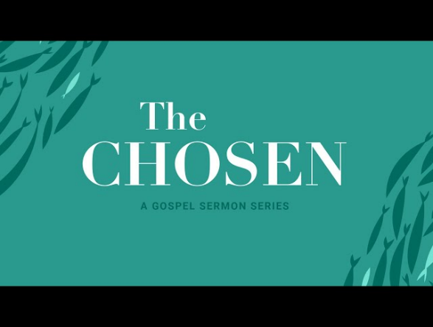

THE CHOSEN

The Small Group Ministry Team’s recent survey indicated that there is great interest in having the bridge present the first, eight-episode series, on the popular faith-based television series The Chosen.

So, the Team is pleased to inform you that for eight Wednesdays, beginning June 17th thru August 5th at 1:30PM, we will meet to view and discuss each episode in the sanctuary.

Many of you are familiar with this series and know you will see Jesus and his disciples come alive on the screen in this historical fiction. You will see Jesus as very human and when he laughs, cries, shows frustration and grief you will feel like you are standing right next to him. The series is a historical drama based on the life of Jesus and those who knew him. It is set against the backdrop of Roman oppression in first-century Israel, and the series shares an authentic look at Jesus' life and teachings. Since it is a historical drama, where further explanations are necessary, Cathy Boettcher and Steve Dare, the facilitators, will add their researched insights.

This is a great outreach for the bridge so invite a friend to join you. Sign-up sheets are on the table. (PS remember if you miss a week, you can always view at home and not feel lost on your return)

Find Purpose through Service

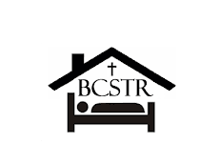

May Mission Partner - Angel Tree Camp

It’s time for Summer Camp!

You may wonder, what are Angel Tree Camps? And what am I being asked to donate?
Angel Tree camps are summer camps for children (ages 5-12) of incarcerated parents. The incarcerated parent has to apply for their child to attend. The sponsor for Brunswick County is Street Reach, one of our sustainable mission partners.
http://www.bcstreetreach.org/

Camp gives the child an opportunity to have fun, fellowship with their peers, build relationships with caring camp counselors, and to experience the great outdoors. These camps are usually traditional church camps located in NC or SC mountain regions.
Supplies needed for campers include: beach towels, sunscreen, and flip flops.

We will be collecting supplies for Angel Tree Camp in May at the Bridge. Angel Tree Camp and Street Reach will also be the mission focus for the upcoming Adult VBS in June. I will be collecting and delivering donations through July 1st.
You can also donate money - $50 still sponsors one camper, but any amount is appreciated!
Last year, the Bridge sent 43 kids to camp!
Please but “Angel Tree” in the memo of your check, or give online – just use the Angel Tree Drop Down option

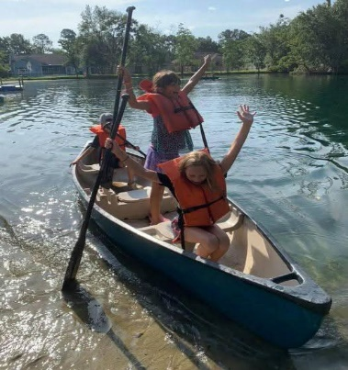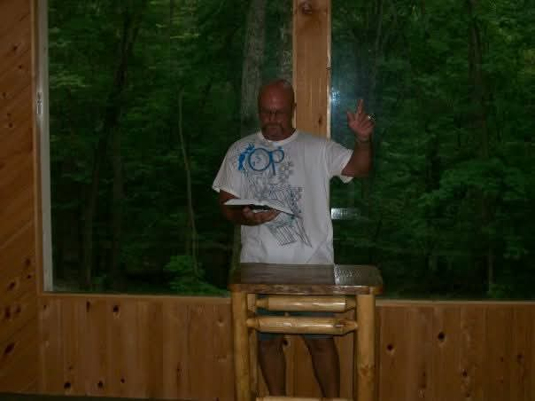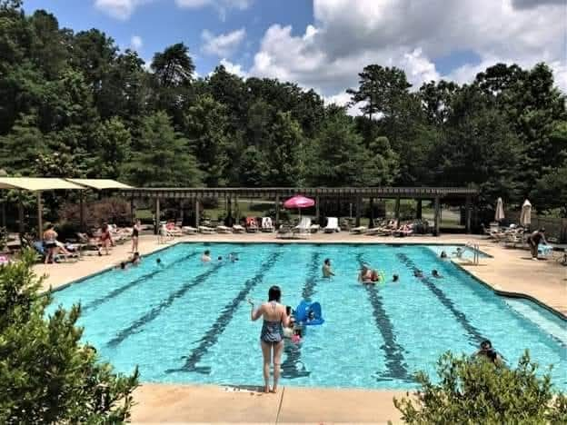
Find Purpose through
Service



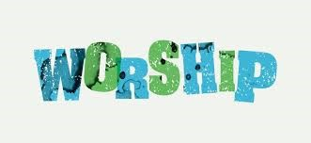
Our next Worship Service at The Bluefields Memory Care will be Thursday, May 7th at 1:30p.m. in the Activities Room. Volunteers are needed to help the residents with songbooks, purchase/serve cookies, sing along, and enjoy worshiping God with our Bluefields friends.
If you would like to join us in this ministry, please wear your bridge tee shirt, if you have one, and arrive by 1:20p.m.For more information or if you are bringing cookies for the residents, contact Susan Stanewick at sstanewick@gmail.com


Our next Craft Day at The Bluefields Memory Care will be
Thursday, May 28, at 2:00 p.m. in the Activities Room.

If you would like to join the fun in helping our friends, please arrive by 1:45 and wear your bridge tee shirt, if you have one.
Any questions please email Patti Pirher at ppirher@gmail.com

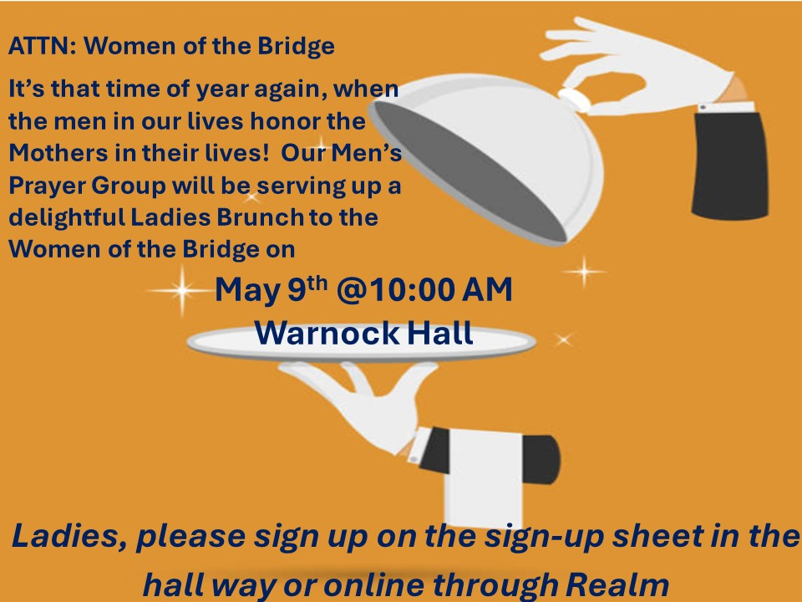


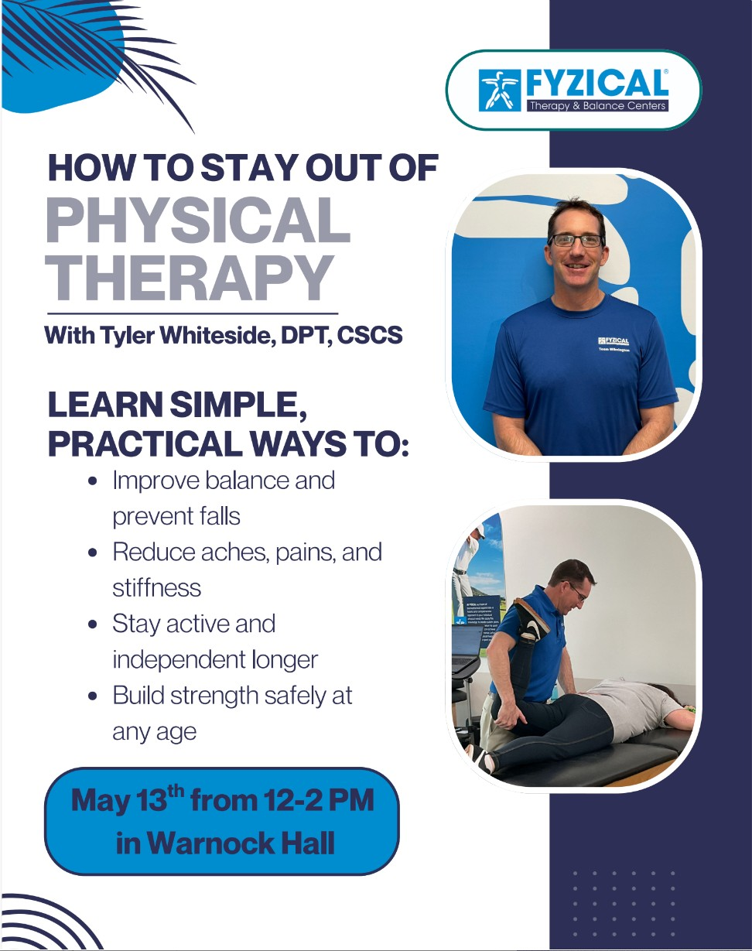



9 Hole Golf on May 21st

The course will be TBA. The target for tee times will be 10:00am.
Sign up Sheet in the hall.

Email Ed Weihs with questions - edweihs2015@gmail.com
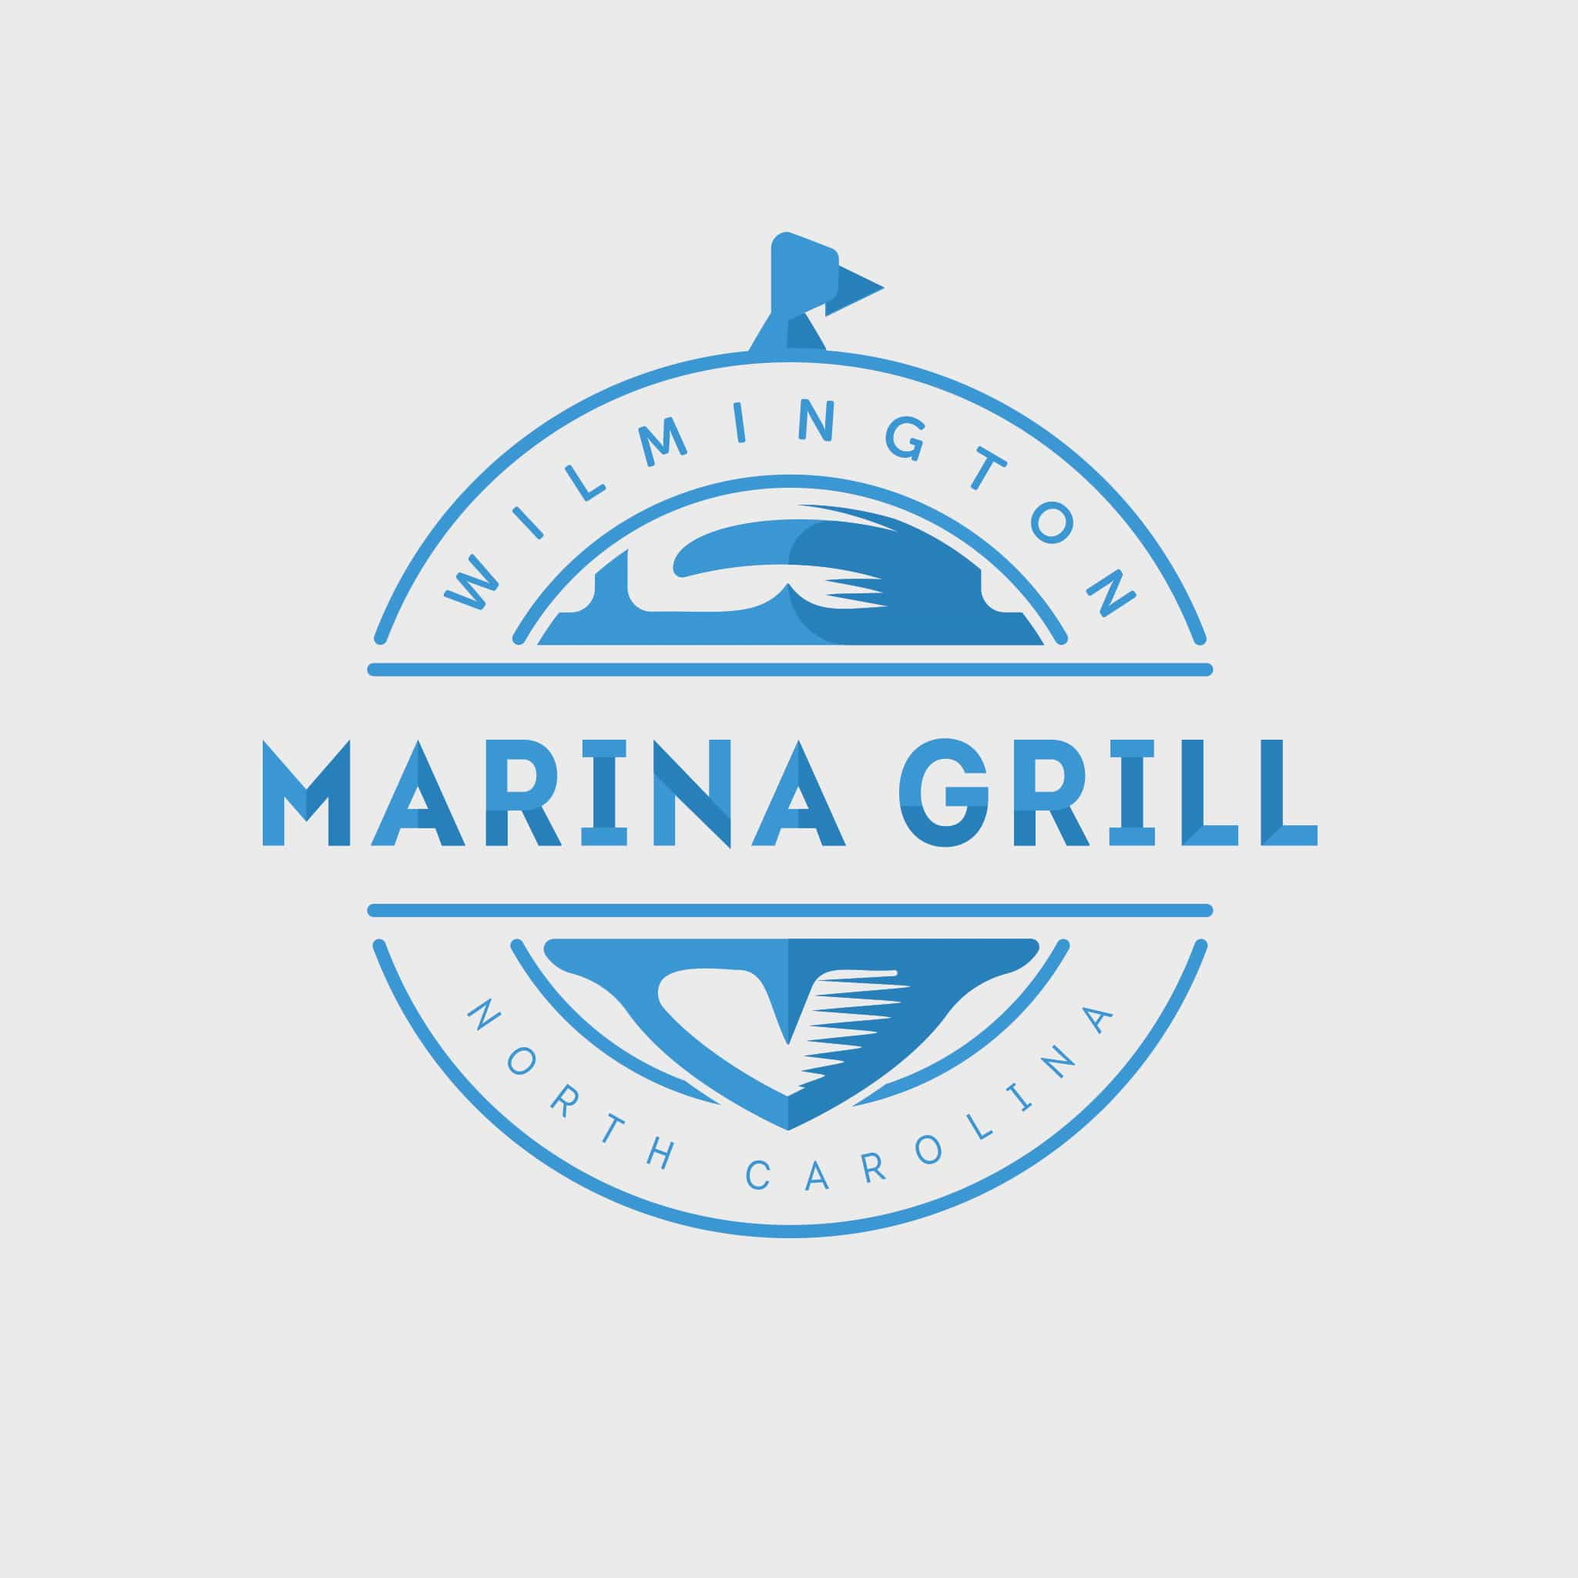

Breaking Bread Fellowship Group

Our May Luncheon will be

Friday, May 29th at 12 Noon

Marina Grill
18 Harnett St
Wilmington, NC 28401

Hosts: Ed and Jane Hoeft

Please RSVP by May 26th

on REALM or sign up in the hallway

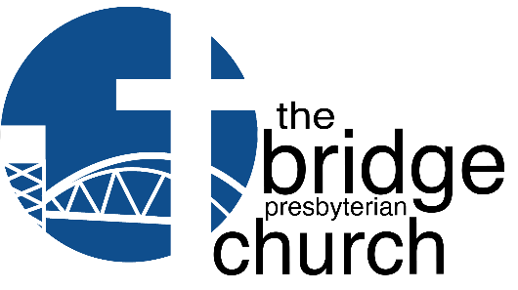
June 9th - 11th
6:00 pm - 8:00 pm
Adult
Vacation
Bible School
FUN
CRAFTS
BIBLE STUDY: Hope Dies Last
FELLOWSHIP
WAYS FOR MORE INFORMATION AND/OR TO REGISTER
• Forms on sign up table in hall
• On REALM
• Email us at : thebridgepres@gmail.com
• Call the office at 910-769-4951

Leland Campus: 1444 Lanvale Rd, Leland, NC

Free Event - Donations will be taken for
STREETREACH
SNACKS
Please Return by May 24, 2026

Vacation Bible School

June 9th – 11th from 6:00 – 8:00 pm

SAVE THE DATES

Information coming soon for you to sign up.

Mark your calendars and begin inviting friends and neighbors to attend with you.

Practice a Christ-Centered Active Lifestyle

Introducing Active Adults on the Go!

Beginning in April, the Activities Team will offer a monthly activity to help keep the ACTIVE in our active adult church! It may be a well-being class, learning a line dance, or taking a field trip!

Keep an eye on Currents and the Bulletin Board for more info!

Month | Event | Date
Practice a Christ-Centered Active Lifestyle

May | How Not to End Up in Physical Therapy with Dr Whiteside DPT, CSCS, of FYZICAL Therapy and Balance Center of Wilmington | May 13  Noon – 2:00
Jun | Line Dancing with Linda – so we can show off our stuff at July’s Beach Concert Linda teaches line dancing at several venues in/around Leland No Cost for participants | June 18  2:00- 3:00 PM
Jul | Beach Concert – Holden Beach  We’ll carpool to the beach and enjoy an evening of Beach Music and Dancing | July 12
Aug | Karen Beasely Turtle Rehab - Carpool to Surf City and learn about the gentle and amazing Sea Turtles! (Who knows, we might even run across the children’ book, Bravery – A Baby Sea Turtles First Adventure, illustrated by our own Lisa T. Myers!)
Sep | Ministry Fair – more to come on this!
Oct | Christian Illusionist – an Alternative to a traditional Halloween!
Nov | Tech Talk – Yes, we’re going to offer it again for the folks who missed it the first time!
Dec | Mike’s Farm – A Christmas variety show, a buffet dinner, and a hayride through the Farm’s spectacular light show! (Depending on transportation arrangements)

Celebrate Life’s Milestones

May
Birthdays Anniversaries
Karen and Joe Santone | May 4th
Greer and Tom Broadwater | May 10th
Charlie and Pat Smith | May 12th
Marge and Tom Hall | May 20th
Kiza and Amani Masanga | May 20th
Mike and Sharon Wilt | May 26th
Brenda and James Bozeman | May 30th
Steve and Theresa Skerlick | May 31st
Thomas Hall | 1
Karen Santone | 8
Dana Erbe | 11
Clyde Queen | 11
Manny Rosenfeld | 11
Marybeth Christiano | 15
Peg Clark | 16
Greer Broadwater | 19
Kerrin Polaski | 20
Laura Patterson | 24
Marilyn Vernon | 24
Patricia Shaffar | 29
Mike Wilt | 29

Here is a life milestone/celebration.
Our son, Justin graduated from Northeastern Law School this past week.
Tom and Marge Hall

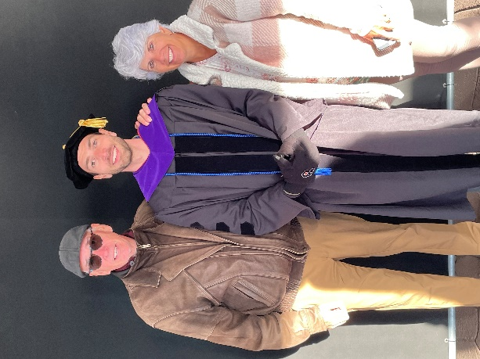
Upcoming Happenings

May
6th - Session - 3:00
7th - Bluefield Worship - 1:30
9th - Women of the bridge - 10:00 - Mother’s Day Brunch
9th- Founder’s Day Festival
13th – How Not to end up in Rehab workshop – Noon – 2:00 pm
25th - Office Closed for Memorial Day
28th - Bluefield Craft - 2:00
31st - 5th Sunday - ONE SERVICE 10:30 - Invite a Friend Sunday – Potluck



Thank you to all who donated used towels for the Veterinarian Hospital next door.
There is thank you note on the welcome table with a few magnets for those who would like one.

